IxD comparison

C. Heesakkers

2023

Menu navigation
Method of testing: Researching how easy it is to navigate to salon / coffee tables

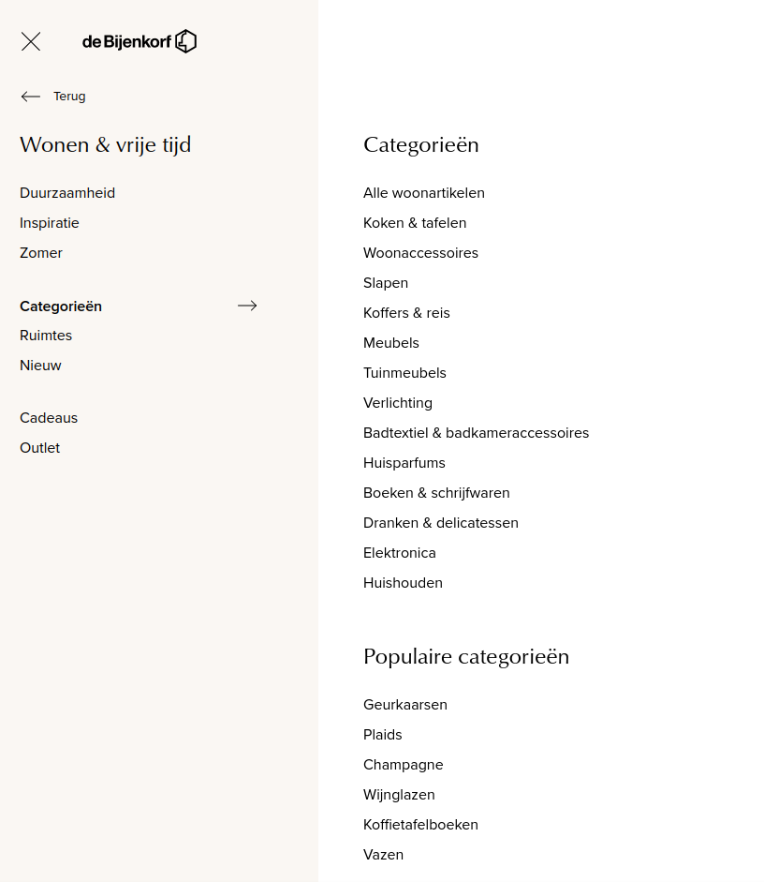
Bijenkorf
Bijenkorf does not have visible navigation in the header, instead, there is a menu button in the top right which you press. From here you press another button for “living and pasttimes”, here you press another button to view categories, where you then click on “furniture”, afetr this you land on a general page for furniture, and you can select the “tables” option in the filters on the left. After applying this filter, you see all tables, but no option to view only salon / coffee tables.

Wehkamp
On Wehkamp, it is very easy to navigate to the salon/coffee tables, as there is a simple header containing different categories, including furniture. The header has very large lists of products, which makes it a bit hard to find what you’re looking for quickly

Trendhopper
At Trendhopper, which specializes in furniture, it is by far the easiest to navigate to the salon / coffee tables, as in their header you can find a button to go directly to the tables section, and from there you can go to salon tables, without hassle

Conclusion
Trendhopper has the easiest navigation in this regard, Wehkamp still does well but falls a bit shorter due to being less specialized than Trendhopper, and De Bijenkorf fails to show a page for only salon / coffee tables

Filter & sorting
Method of testing: Try to find a round, wooden, black salontable.

Bijenkorf
At Bijenkort, I can filter by color, so I choose the black color.
Then, I can also filter by only wood, so now I see tons of different kinds of tables, some of which are salon tables.
I can also sort by age, price and relevancy

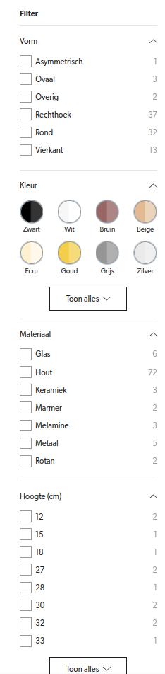
Wehkamp
At wehkamp the first filter I see is an option to show only tables of a certain color, so I select the color black.
After this, I can select the shape, so I choose round
Lastly, I get an option to choose the material, so I will choose wood.
I can now see only black round salontables in the products section.
I can also sort by price recommendation, name, age and discount

Trendhopper
At Trendhopper I cannot filter the salon tables, which means I have to look through all salon tables to find a correct one, which takes more time.
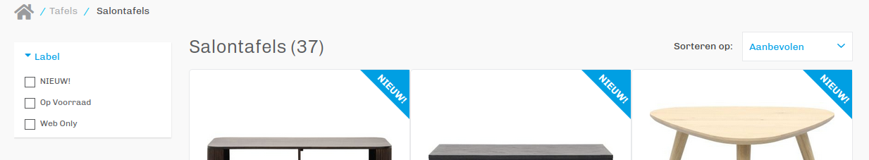
I can however sort by price, name and recommendation

Conclusion
Wehkamp had the best filtering and sorting system, allowing me to easily find exactly what I want, Trendhopper has absolutely no filtering system, and Bijenkorf has a reasonable system, which is unfortunately ruined by being unable to filter only salontables, making the page a big mess.

Compare products
Testing method: select two different tables to compare and see what points the different websites offer.

Bijenkorf
Bijenkorf has no comparison functionality

Wehkamp
Wehkamp has no comparison functionality

Trendhopper
Trendhopper has no comparison functionality

Conclusion
None of these furniture sites have comparison functionality, which points to a general consensus that there is no need or use for a comparison function for these kinds of products.

Add to shopping cart & delete
Testing method: Check what happens when adding and removing soemthing from cart.

Bijenkorf
Adding something to the shopping cart shows a left sidebar shopping cart, with the new product in it.
Removing something from the shopping cart removes the product from the cart, and then refreshes the cart sidebar.

Wehkamp
Adding something to the shopping cart shows the contents of the shopping cart on the left hand side of the display, and it gives some options for what to do.
Removing something from the shopping cart removes it and shows a message asking if you want to undo that action.
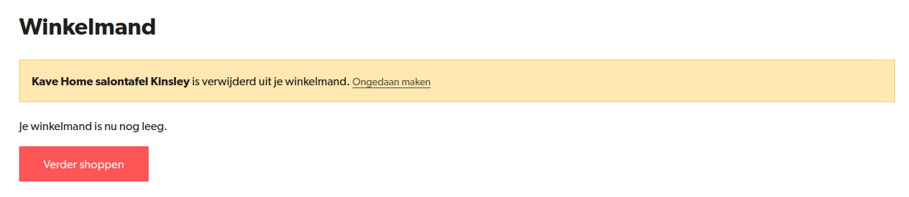

Trendhopper
Adding something to the shopping cart moves to user to the shopping cart page.
Removing something from the shopping cart shows no message, and instead only removes the item from the cart.

Conclusion
Wehkamp shows that you removed something, and gives to option to undo, bijenkorf and trendhopper remove the items without question.

Checking out
Testing method: check out an item and observe how the process works

Bijenkorf
When you proceed to checkout at Bijenkorf, you are given the option to log in, register, or proceed as a guest. After this, you fill in your personal info and delivery options in the same page, then you proceed to payment. On the payment page, you can see what you are buying and continue to your payment provider.
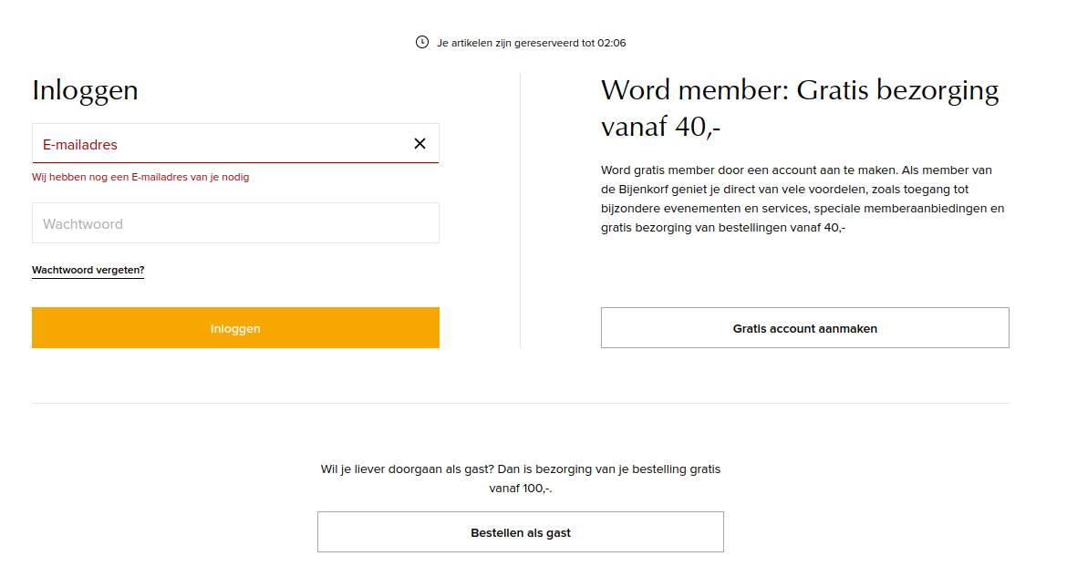

Wehkamp
To order something at Wehkamp you are forced to first log in, after doing so, you land on a page to first select delivery method, and then the payment method, after which you can press a button to immediately be sent to the payment provider.

Trendhopper
When ordering something at Trendhopper, you land on a page to first fill in your contact information and calculate the delivery costs, after this, you select how you will pay, after which you are sent to your payment provider and then back to trendhopper to receive a confirmation of payment.
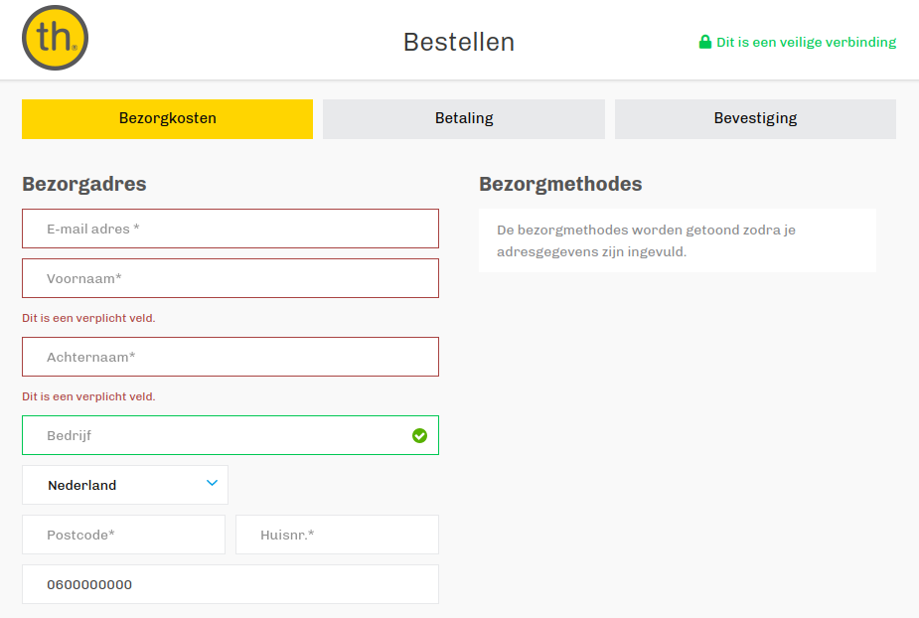

Conclusion
Bijenkorf has a more user friendly system by allowing users to choose not to make an account, meanwhile Trendhopper gives a showcase of how many parts of the check out process there are, but Wehkamp doesn’t add anything of value.

Unhappy flow
Testing method: Go to a page that does not exist within the website to see what error is given.

Bijenkorf
When you go to a page which does not exist, Bijenkorf gives a 404 screen, with suggestions on where you can go instead.
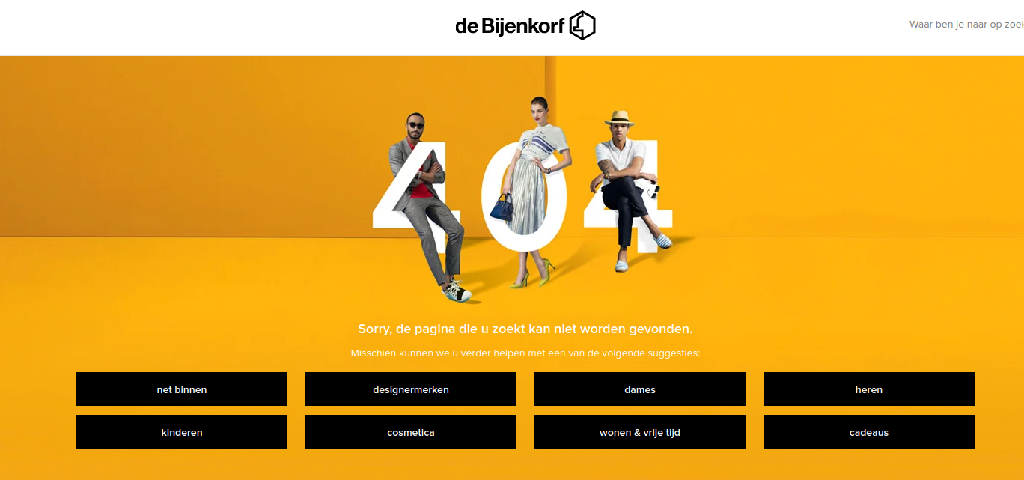

Wehkamp
Wehn going to an unknown page on Wehkamp, you see a screen informing you the page you seek cannot be found. Below that message, is a searchbox, prompting you to go elsewhere on the website

Trendhopper
When going to an unknown page, Trendhopper shows a mostly empty screen, which tells the user that page cannot be found.
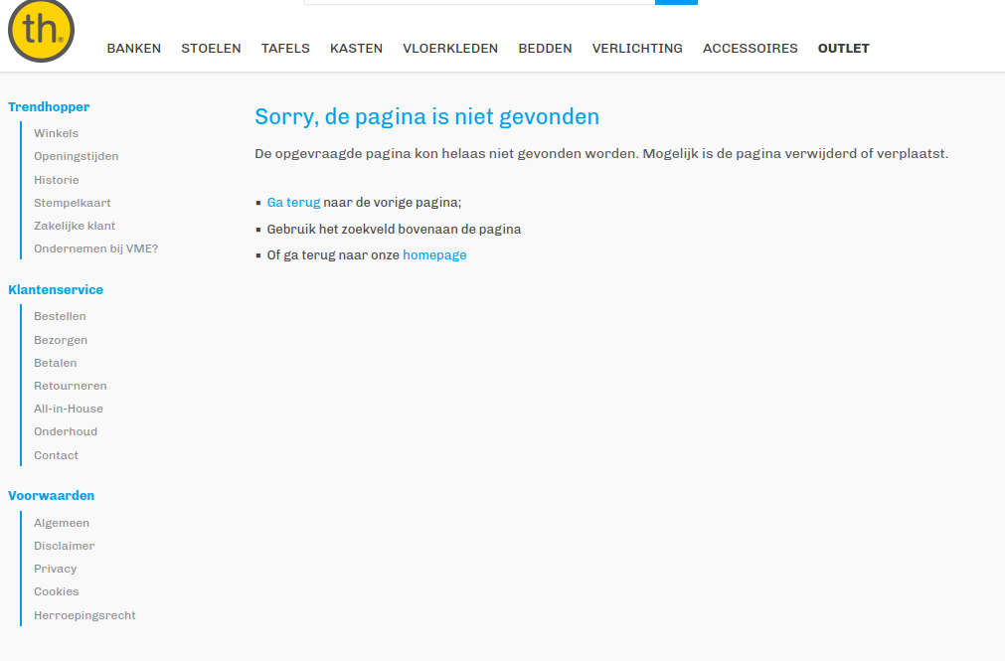

Conclusion
Bijenkorf has the best designed 404 page in my opinion, to such a point it barely feels like an error. Wehkamp comes close, but it does not have as homely of a look as the Bijenkorf page. Lastly Trendhopper has the most bland page, featuring only very basic navigation options.

